EXPT NO:1 | Implementation of data charts
DATE: 06.01.2026 | Implementation of data charts

PRE-LAB QUESTIONS (PROVIDE BRIEF ANSWERS TO THE FOLLOWING QUESTIONS)

- How can visualization help an academic institution improve student outcomes?
Visualization transforms complex tables of marks into clear patterns. It helps institutions quickly identify at-risk students who need extra help, spot difficult subjects where the entire class is struggling, and track progress over time to see if teaching methods are working.

- Which chart types are suitable for comparing subject-wise performance?
- Bar Chart: Best for comparing average marks across different subjects side-by-side.
- Box Plot: Excellent for showing the spread of marks (minimum, maximum, median) and identifying outliers in each subject.

- What type of data scale is used for student marks?
Student marks are measured on a ratio scale. This is because the data has a specific order (Example: 90 is better than 80), equal intervals between values, and a "true zero" point, it is possible to score 0, which represents a total absence of marks.

- Why should raw academic data be cleaned before visualization?
Raw data often contains errors like missing values, duplicates, or incorrect entries (Example: a mark of 105 out of 100). If not cleaned, these errors can skew averages, create misleading charts, and lead to incorrect conclusions about student performance.

- How does visualization support evidence-based decision making?
Visualization converts large, complex datasets into intuitive patterns, making it easier to objectively identify problems or successes. This allows to base the strategies on concrete visual proof rather than assumptions, ensuring resources are targeted exactly where the data shows they are needed.

IN-LAB EXERCISE:
OBJECTIVE:
To design appropriate data charts to analyze and compare academic performance indicators.
SCENARIO:
An autonomous engineering college wants to analyze internal assessment performance of first-year students across five subjects to identify difficult courses and improve teaching strategies.
IN-LAB TASKS (Using R Language)
- Load required R libraries (ggplot2, dplyr)
- Import dataset using read.csv()
- Perform basic data preprocessing
- Create bar chart for subject-wise average marks
- Generate line chart for performance trend across tests
- Plot pie chart for grade distribution

(CODE: CONATAINS STUDENT ROLL NOS
SCREENSHOT OF CODE
SCREENSHOT OF OUTPUT)

CODE WITH OUTPUT:

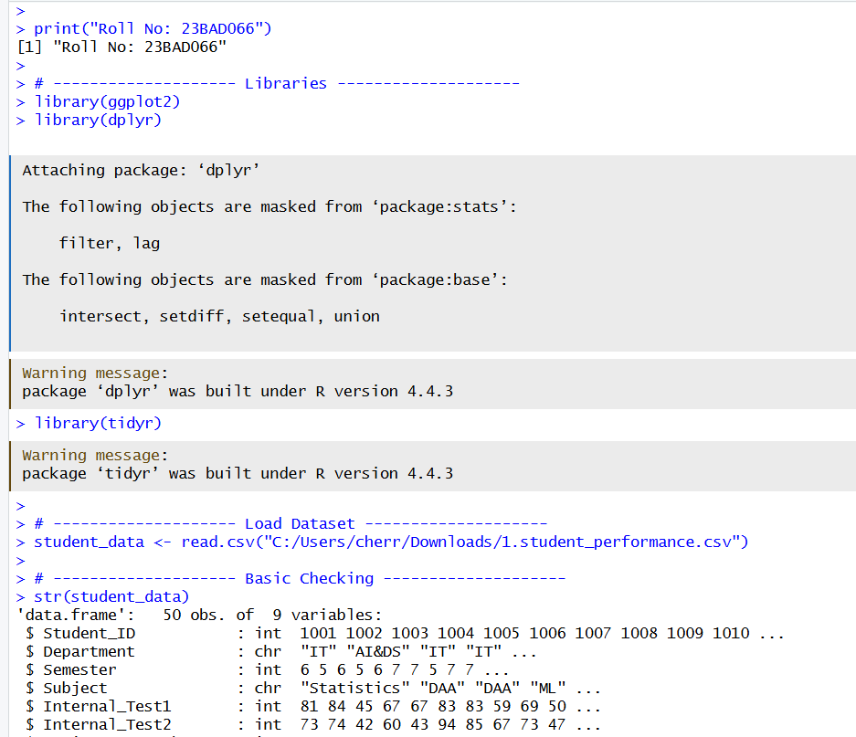

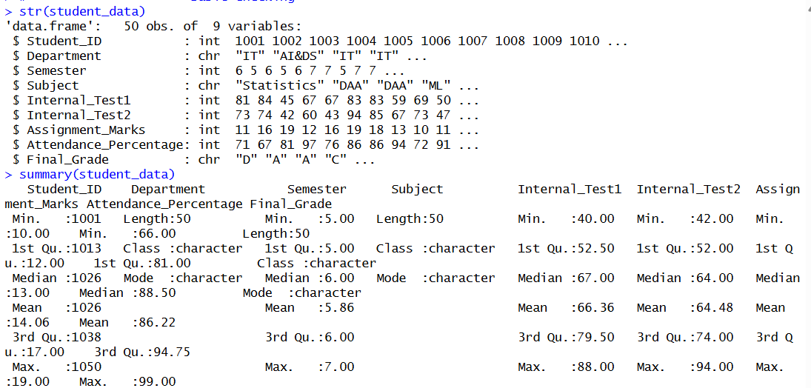

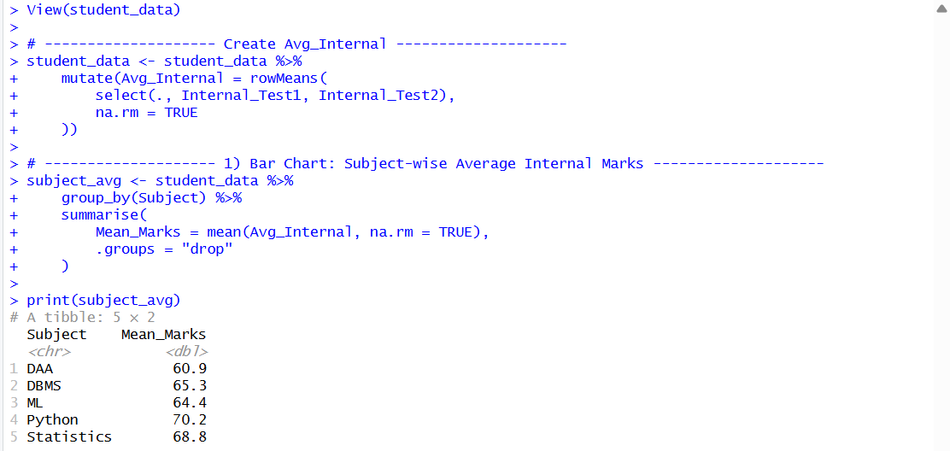
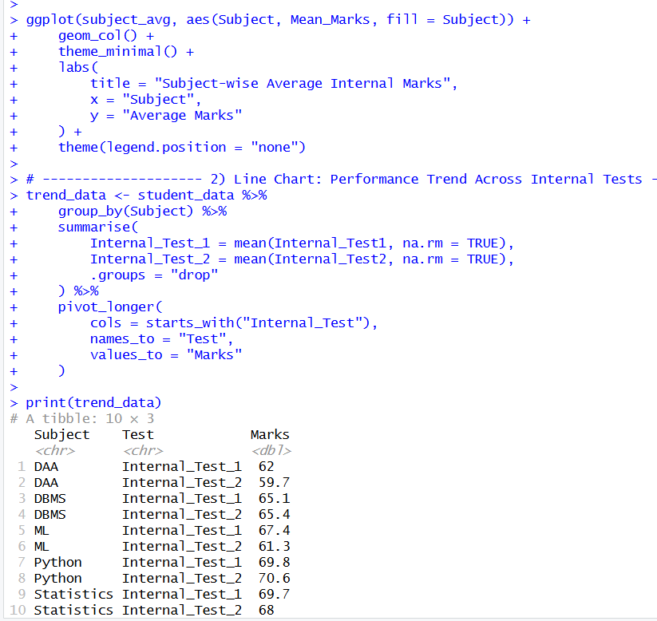

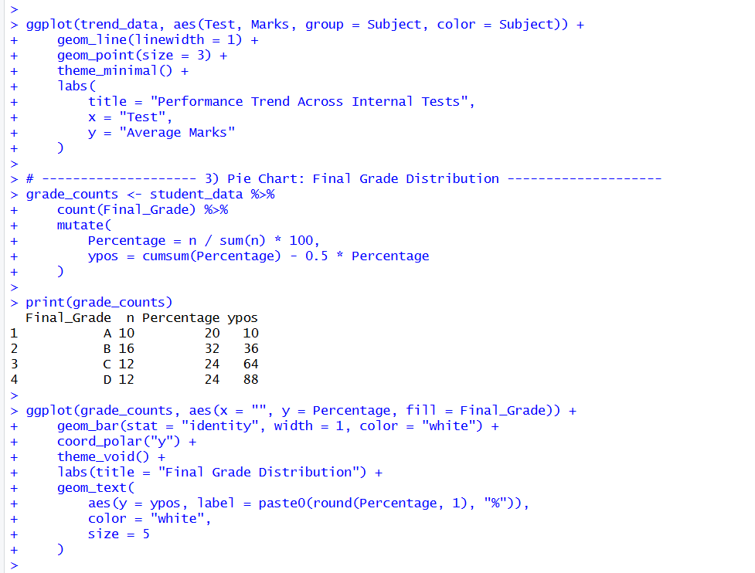

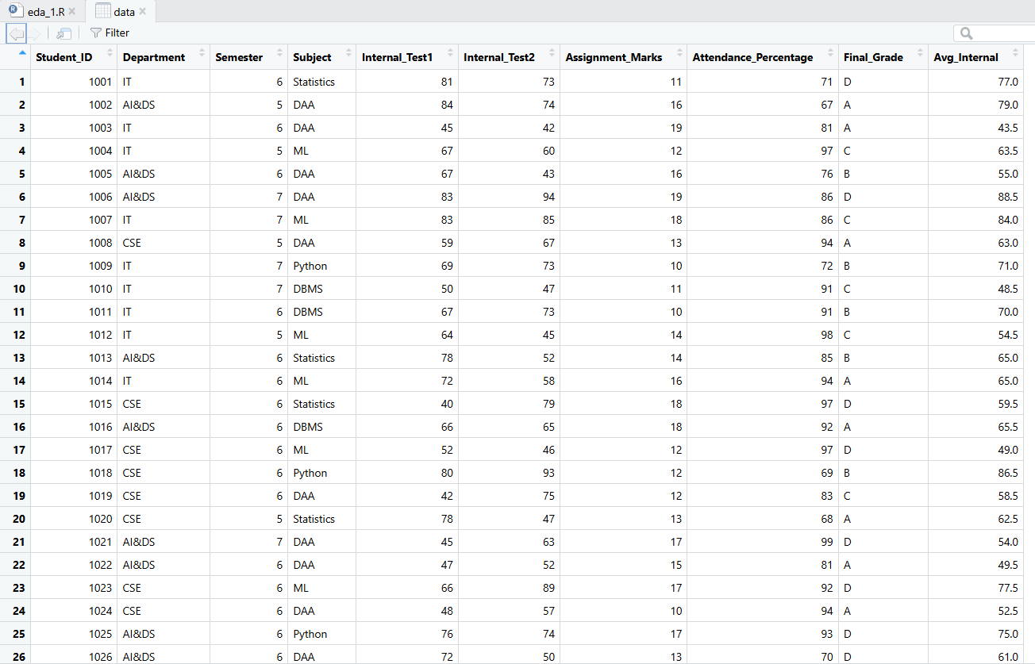

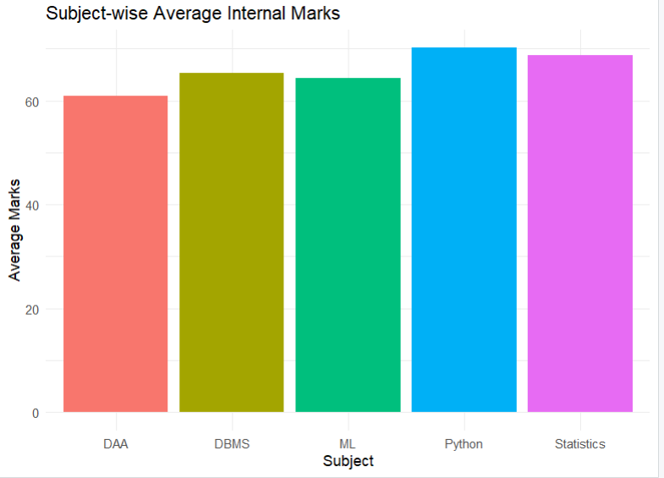
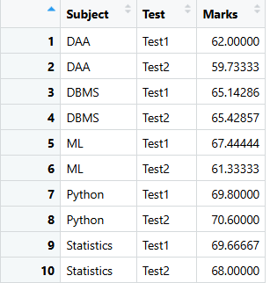

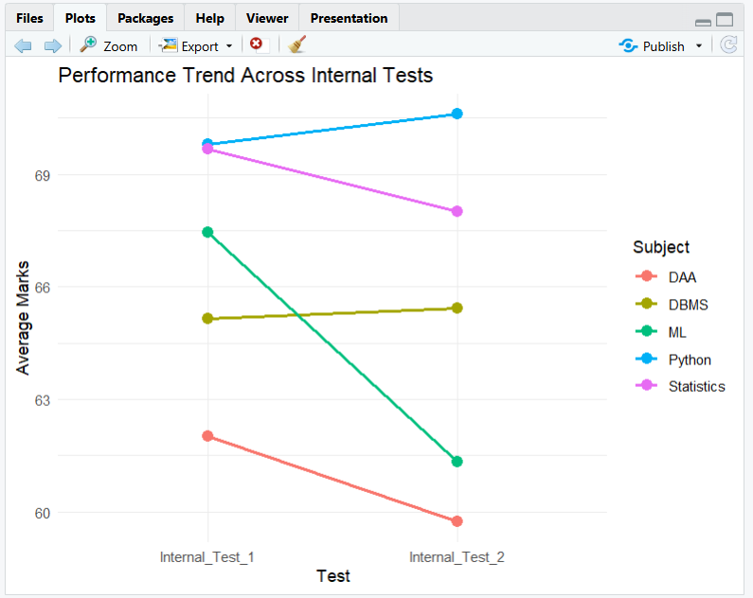

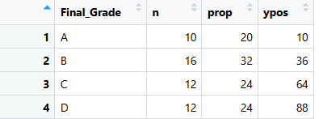

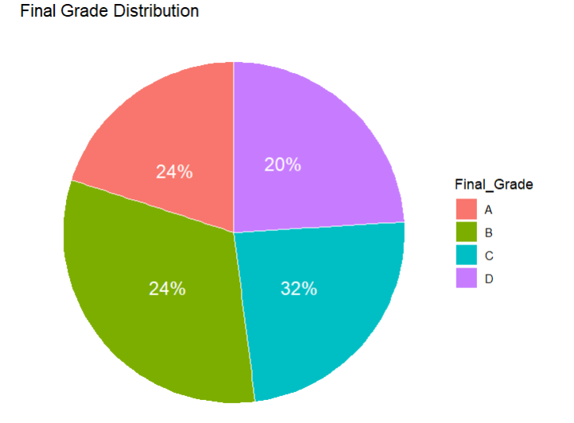

POST-LAB QUESTIONS (PROVIDE BRIEF ANSWERS TO THE FOLLOWING QUESTIONS)
- Which subject shows consistently low performance and why?
DAA shows consistently low performance among all subjects because it has the lowest overall average mark (60.9). It also records low scores in both Internal Test 1 (62.0) and Internal Test 2 (59.7), indicating difficulty in understanding the subject due to its complex algorithmic and problem-solving nature.

- Why is a line chart suitable for trend analysis?
A line chart is ideal because it connects individual data points with a continuous line. This visual continuity makes it instantly easy for the human eye to detect the direction of change (improvement or decline) and the rate of change (steep vs. gradual slope) between Test 1 and Test 2.

- What limitations does a pie chart have in analytics?
Pie charts are limited because they become difficult to interpret when there are many categories or when differences between values are small. They do not accurately show precise comparisons and cannot represent changes over time. As a result, pie charts may sometimes give a misleading view of data distribution.

- How can this analysis help curriculum planning?
This analysis helps curriculum planners identify subjects and topics where students perform poorly. Based on the insights, the syllabus can be revised, additional instructional hours can be allocated, and new teaching strategies can be introduced. It also supports planning remedial classes, tutorials, and assessments to improve student understanding and performance.

- How can such visualizations be integrated into AI-driven academic analytics
Visualizations can be integrated with AI systems to automatically analyze student performance data. AI models can predict at-risk students, detect learning gaps, and suggest personalized learning plans. Real-time dashboards can be generated to support data-driven academic decisions and continuous performance monitoring.

ASSESSMENT
Description | Max Marks | Marks Awarded
Pre Lab Exercise | 5
In Lab Exercise | 10
Post Lab Exercise | 5
Viva | 10
Total | 30
Faculty Signature

